**Unit-I**

1. Define Data Science and write its applications.

2. Explain types of data.

3. Define variable and explain types of variables.

4. Define data visualization and explain various methods to visualization.

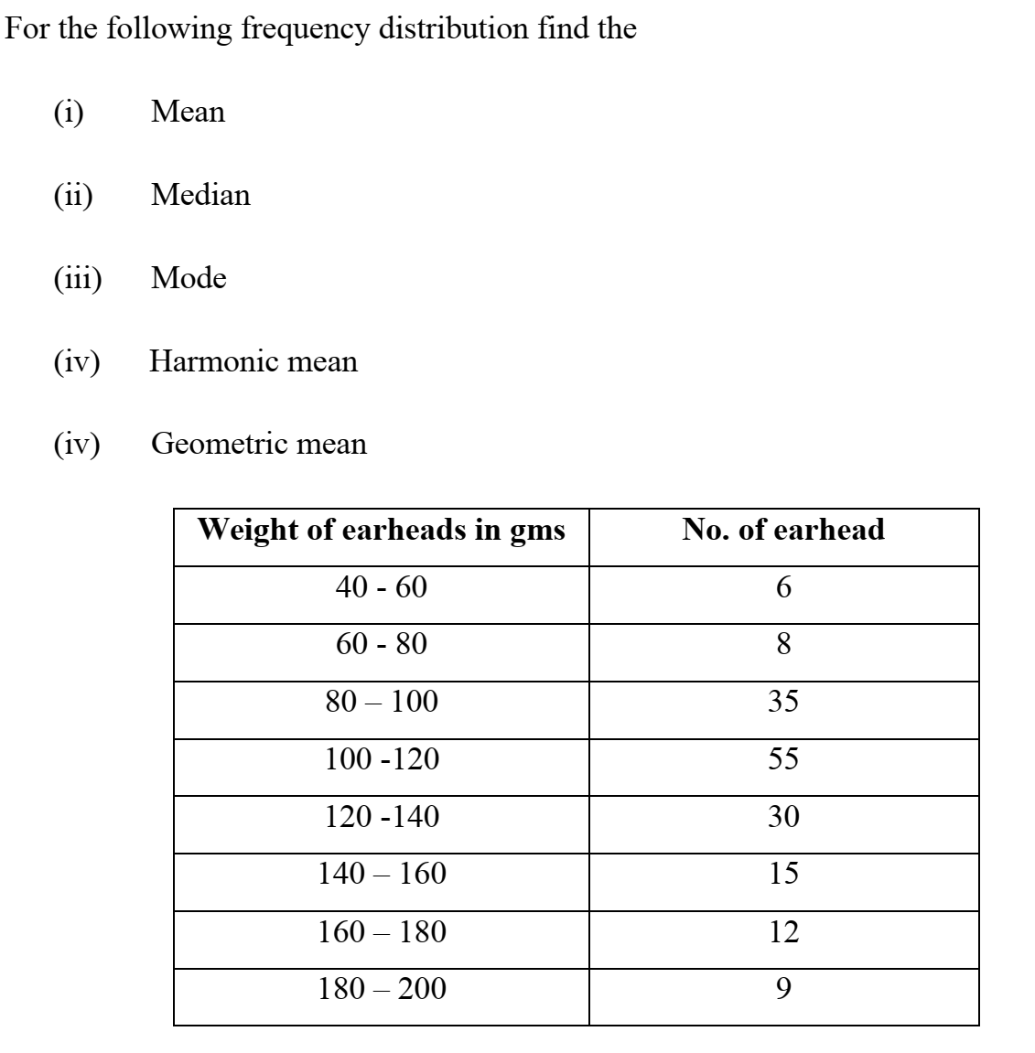5.

|  |  |  |  |  |  |
| --- | --- | --- | --- | --- | --- |
| Weight | **60 – 64** | 65-69 | 70-74 | 75-79 | 80-84 |
| No. of students | 5 | 9 | 16 | 12 | 8 |

6. Find the mean, median, mode, variance and standard deviation of the following distribution

**Unit-II**

1. A bag A contains 2 white and 3 red balls and bag B contains 4 white and 5 red balls. One ball is drawn at random from one of the bags and it is found to be red. Find the probability that the red ball drawn is from bag B.

2. A businessman goes to hotels X, Y, Z 20%, 50%, 30% of the time respectively. It is known that 5%, 4%, 8% of the rooms in X,Y,Z hotels have faulty plumbing. Find the probability that businessman’s room having faulty plumbing is assigned to hotel Z.

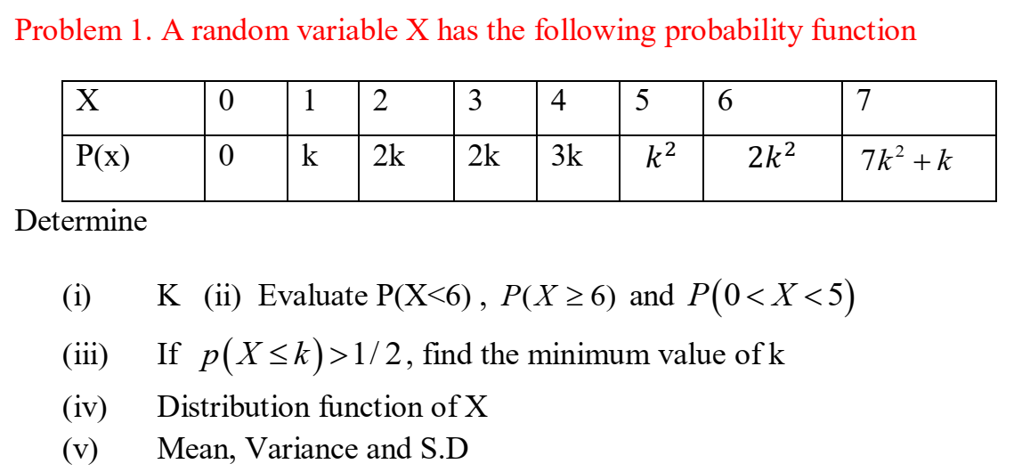3.

4. A random variable X has the following probability distribution

|  |  |  |  |  |  |  |  |
| --- | --- | --- | --- | --- | --- | --- | --- |
| x | 0 | 1 | 2 | 3 | 4 | 5 | 6 |
| p(x) | k | 3k | 5k | 7k | 9k | 11k | 13k |

Find a)k b)mean c)Variance d)P(0<X<5)

5. if X is a normal variate with mean 30 and standard deviation 5. Find the probabilities that i) 26 ii) X

6. In a sample of 1000 cases, the mean of a certain test is 14 and S.D is 2.5.

Assuming the distribution to be normal, find

1. How many students score between 12 and 15.
2. How many score above 18
3. How many score below 18.

7. If the p.d.f of X is given by $f\left(x\right)=ce^{-\left|x\right|}$, find a) c b) $P(0<x<1)$

**Unit-3**

1. If the population is 3,6,9,15,27
2. List all possible samples of size 3 that can be taken without replacement from the population
3. Find the mean of the sampling distribution of means**.**

2.If the population consists of 2,3,6,8,11. Draw all possible samples of size 2 from the population without replacement. Find the mean of the sampling distribution of means**.**